**Node JS Fundamentals**

**Node JS did not have a window object**

**Global Variable In Node is following**

const  node = "Node tutorial";

console.log(node);

//Global--NO window!!!!

//in node there is no window

//__dirname=path to current directory

//__filename=file name

//require=function to use module

//module-info about current module

//process-info about env where the program is being executed

console.log(__dirname);

console.log('===========================================');

console.log(__filename);

console.log('===========================================');

console.log(require);

console.log('===========================================');

console.log(module);

console.log('===========================================');

Output for console.log(require) is mentioned below

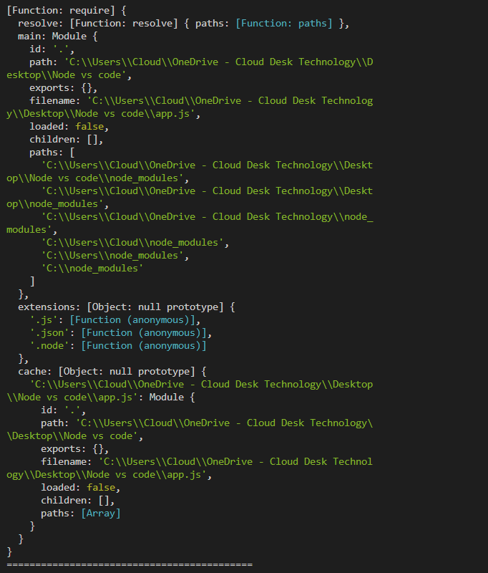

**Output for console.log(module) is mentioned below**

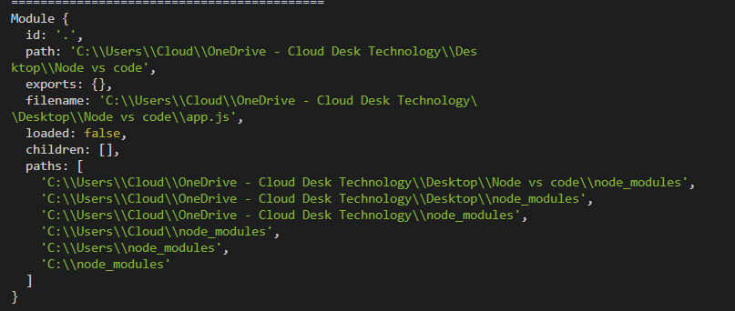

**Modules in Node**

**(Basic example code)**

const  node = "Node tutorial";

console.log(node);

//module

const sayHi=(name)=>{

console.log(`Hello there ${name}`)

}

sayHi('Pravin');

sayHi('rajesh');

sayHi('Kumar');